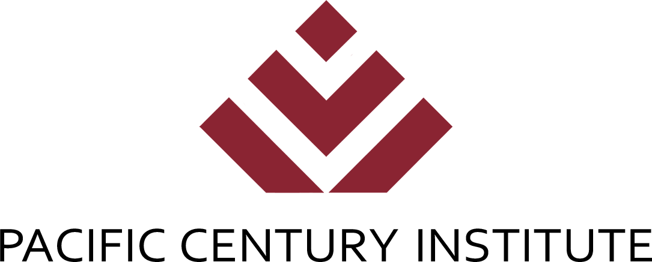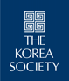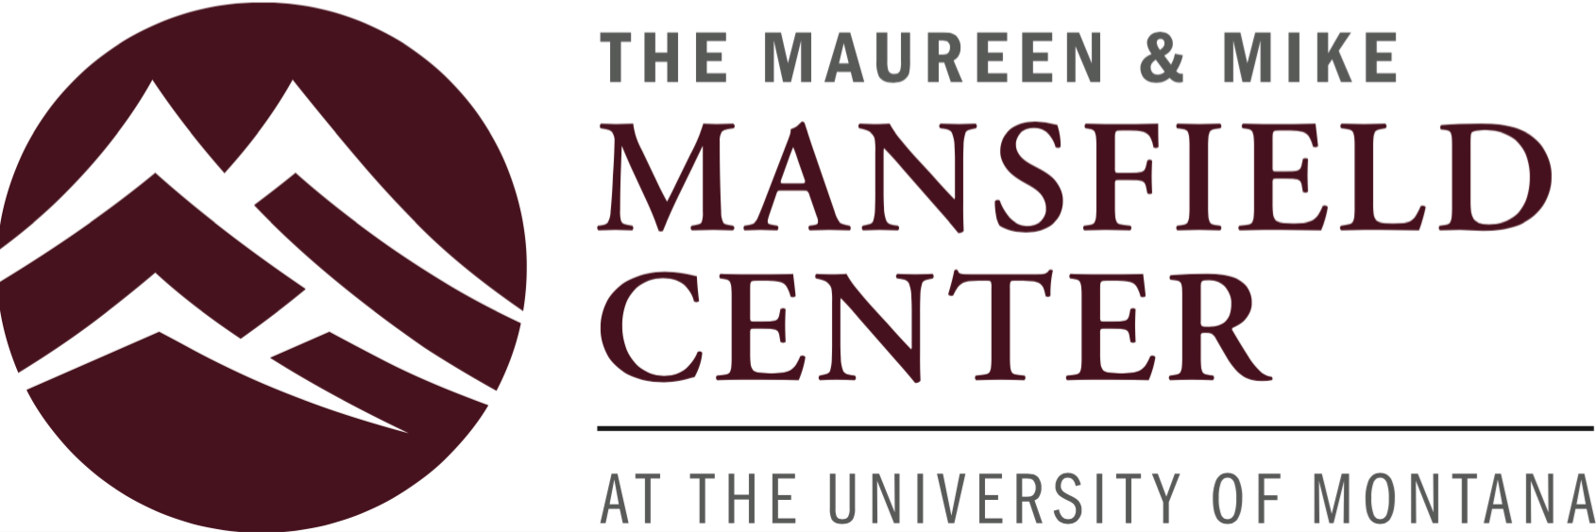

Project Bridge Youth Ambassador

2019-2020 Project Bridge Recommendation Form

Thank you for assisting The Korea Society in our Project Bridge selection process. Project Bridge is an intercultural youth leadership program that includes bi-monthly educational workshops held at The Korea Society in Manhattan and a fully paid ten-day study tour to the Republic of Korea. Juniors and seniors in NYC public schools are eligible to apply.

If you have any questions regarding the program or this form, please contact Linda Tobash, Project Bridge, The Korea Society, 350 Madison Avenue, 24th Fl.,New York, NY 10017 or by email at linda.tobash@koreasociety.org.

Note: Feel free to use this form or to copy the questions onto separate sheets of paper. Please type or print clearly.

Student name: ___________________________________________________

Your name: ______________________________________________________

Your relationship to student: ________________________________________
(e.g., math teacher, coach, employer, etc.)

How long have you known the student? ________________________________

______________________________________________________________________

1. Please describe three of the student’s strengths.

2. Is there anything special or unusual about the student? Are they distinguished in some way?

3. What would you describe as a key weakness or area where growth is needed? Please be candid.

4. Out of the students you have known, how would you evaluate this student? (Mark one)
___Excellent ___Above Average ___Average ___Below Average ___Poor

5. Additional Comments:

______________________________________________________________________

In summary, please mark one of the following:

_______I strongly recommend this applicant. _______I recommend this applicant.
_______I do not recommend this applicant. _______I have some reservations.

______________________________________________________________________

School or company at which you work: _____________________________

Telephone:______________________________________________________

Email: __________________________________________________________

Signature: _______________________________________ Date: _________

Please place this completed form in a sealed envelope and sign your name across the sealed, back flap. You can return to the applicant or mail directly to:
Linda Tobash
The Korea Society
350 Madison Ave., 24th Fl.
New York, NY 10017

RECOMMENDATIONS MUST BE POSTMARKED BY FRIDAY, OCTOBER 11, 2019.

